# **ANNUAL EXAMINATION - 2077**

**Grade: VIII Full Marks: 50**

**Subject: Science Pass Marks: 20**

**Time: 1 hour and 30 minutes**

**Group A: Physics [20 Marks]**

* 1. Define fundamental unit. Write the fundamental units of mass and temperature in SI system. [1+1]
  2. Define acceleration. Motor travels with the speed of 30m/s, how far does it travel in one hour. [1+2]
  3. What is meant by 1 pascal pressure? Prove that p=hdg. [1+2]
  4. What is thermometer? In which principle does it base on? [1+1]
  5. What is concave mirror? Answer the following questions on the basis of given diagram. [1+1+1]

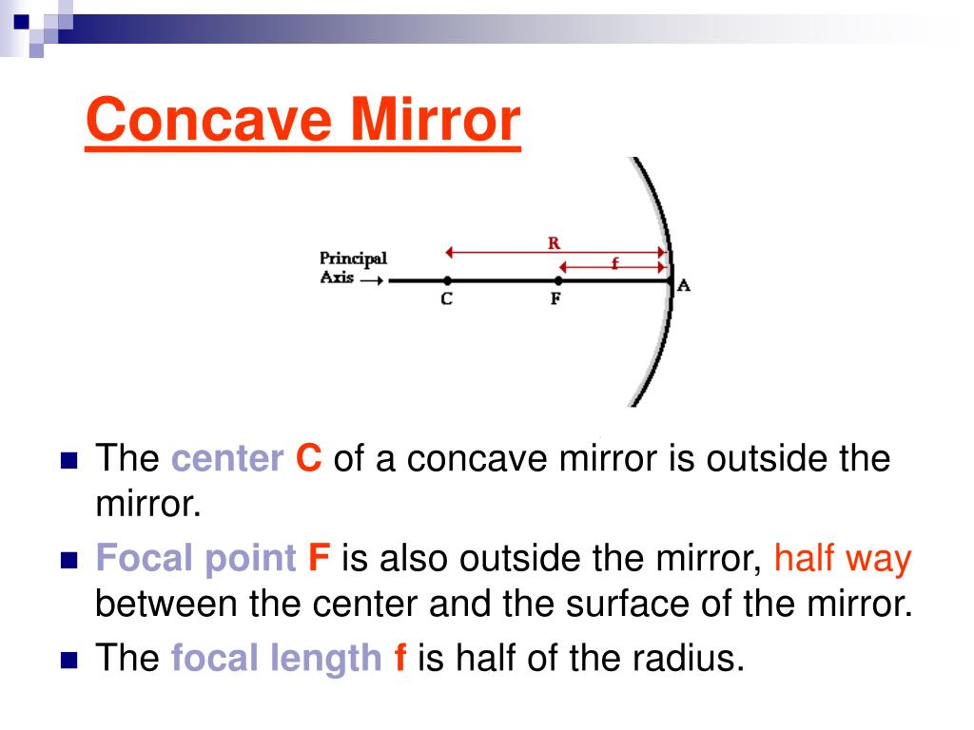

* + 1. What type of mirror is shown on the figure?
    2. Write any two properties of image formed.
  1. What is lever? Why is velocity ratio always greater than the mechanical advantage? [1+1]
  2. What is reverberation? Big cinema halls are carpeted and made of some rough materials. Why? [1+2]
  3. What is the full form of MCB? A dry cell does not have polarization. Why? [1+1]

**Group B: Chemistry [10 Marks]**

* 1. Define molecular formula. Write down the molecular formula of given compounds by crisscross method. [1+1+1]
     1. Sodium chloride
     2. Aluminum chloride
  2. What is centrifugation? Which methods are used in separating mixture of? [1+0.5+0.5]
     1. Sand and camphor
     2. Blue ink and red ink
  3. Draw atomic structures of oxygen atom and sodium atom. [1.5+1.5]
  4. Write two properties of salt. [2]

**Group C: Biology [10 Marks]**

* 1. What is virus? Draw a neat of bacteriophage virus. [1+2]
  2. What is meristematic tissue? Write one function of xylem. [1+1]
  3. What is blood? Write two differences between RBC and WBC. [1+2]
  4. Write two differences between monocot seed and dicot seed. [2]

**Group C: Long Question Answer [10 Marks]**

* 1. What is timber tree? Name any two medicinal herbs found in Himalayan region of Nepal. [1+1]
  2. What is greenhouse effect? Write its two causes and two effects of greenhouse effect. [1+1+1]
  3. Write any two functions of WWF. [2]
  4. Define sustainable development. Mention it’s any two principles. [1+2]

*Best Wishes!!!*